Table of Contents
2 Software Process Model 2
2.1 Model: 2
2.2 Why V-Model? 2
3 Project Requirements 2
3.1 Functional Requirements: 2
3.2 Non-Functional Requirements: 3
4 Activity Diagrams 4
4.1 Login and registration 4
4.2 Cash Withdrawal 5

Project: ATM Simulator
Members:
Aetesam Asfar Ullah - 092
Anas Umar Khan - 051
Anas Niaz -106

Software Process Model

Model:
The most suitable software process model for this project “ATM Simulator” would be Verification and Validation Model (V-Model).

Why V-Model?
In banking system like ATM Simulator, the most important thing is ensuring security and reliability. Security breaches and transaction failure can cause huge losses. In Verification and Validation Model, the testing is done in parallel with development phase. It provides strict testing after every module. This helps in proactive defect tracking, finding defects early on and making sure security is integrated properly, making it perfect for financial application like ATM Simulator.

Project Requirements

Functional Requirements
- Login/Logout
- Registration
- Deposit
- Cash Withdrawal
- Check Balance
- Mini-Statement
- Change PIN
- Insufficient Balance Check
- Data Encryption
- Manage Accounts (For Admin)

Non-Functional Requirements
- Database Connectivity
- User-Friendly Interface
- Development in Java
- UI based on Java Swing
- Responsive Design
- Multiple User Handling
- Transaction Notifications
- Maintainable
- Secure Transactions
- Fast Transactions

Activity Diagrams

Login and registration

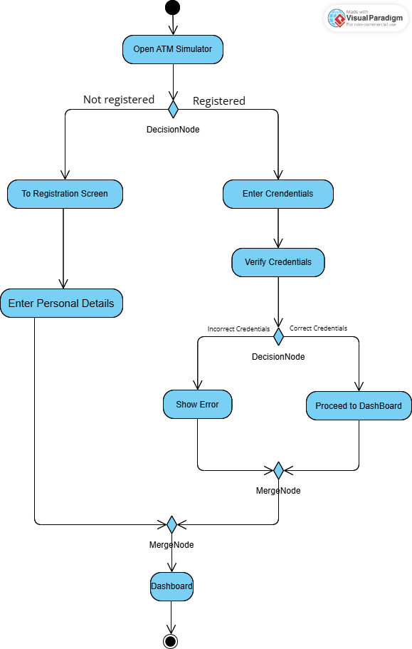

Cash Withdrawal
